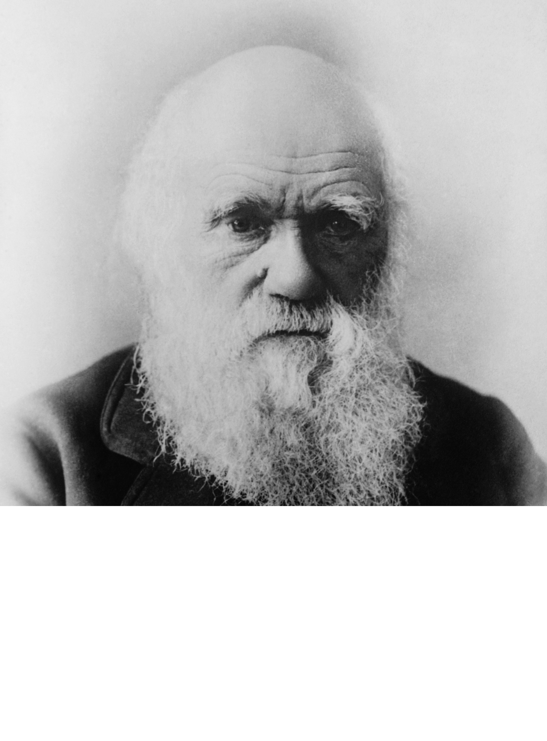the

**DARWIN GAME**

**2011 Pro-League**

*Now open to the entire community.*

Create an artificial intelligence creature using a simple Java API and watch it come to life!

E-mail XXXXX now to register for the mailing list and SDK.

Natural Selection tournament at XXXXXXX at CS Snacks.

McGuire:Projects:CS136:darwin2.1:source:GenoSS-E.pngMcGuire:Projects:CS136:darwin2.1:source:Flytrap-E.pngMcGuire:Projects:CS136:darwin2.1:source:Apple.pngMcGuire:Projects:CS136:darwin2.1:source:PsyduckATS-E.pngMcGuire:Projects:CS136:darwin2.1:source:Tortoise-E.pngMcGuire:Projects:CS136:darwin2.1:source:Hero-E.png